**Pak Shing Kan, Ryan Kwong, Varun Reddy Mallepally**

**Team 10**

**CS157A Fall2020**

**Project Description**

Santa Clara County community has a lot of diversity, which has been predominantly a safe county to live in. However, in the past few years there has been an upsurge in the crimes reported. Most important out of these are juvenile crimes, shootings, robberies, and sexual assaults. Most of these crimes are being unreported. (Santa Clara County District Attorney’s Office, 2018)

Our project is a dynamic web application that is based around the idea of helping people in Santa Clara county to socially connect and share any crime updates, alert people about any mishaps, communicate with law enforcement, educate people about different crimes, and give a chance for people to anonymously share their crime experiences. This will help the people in the county to become more aware and alert. Even though there is an active amber alert system in each county, it is more of a one- way communication by the cops to the people. Through our web app we will provide browser notifications, where you can access not only alerts, but also any pictures or videos or posts, thus promoting two-way communication. We will give special account access to cops where they can login using special identification validation and certify if the information people are posting is legitimate or not. If not legitimate, then they can specify the reason why it is illegitimate and pull the post down.

**System Environment**

System Structure

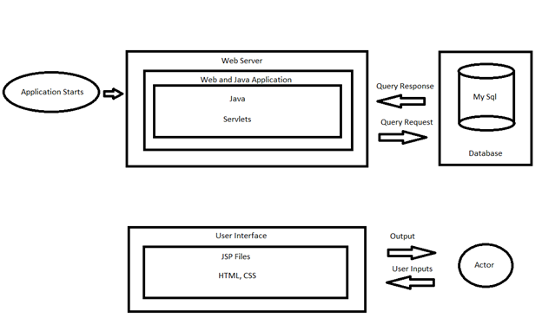

**Hardware and Software Used:** Apache Tomcat, React.js

**RDBMS:** MySQL

**Application Languages**: JAVA, JSP, SQL, HTML,CSS, JavaScript

**Functional Requirements**

This application provides functionality for our three types of users, viewers, posters, and authorities. Additionally an admin user is included as a separate type of user.

Viewers will not require an account to view posts but they will have the least access to functions of the application. Viewers are able to search through the posted reports by city.

Posters have the same privileges as viewers in terms of viewing posts. Posters are able to post a report by providing the necessary information (incident, address, etc). Posters can update or edit their post with updated information or clarification. Posters can also search and reply to other users' posts that are pertaining to the same crime.

Authorities will have access to the poster’s contact information in order to follow up on reports. They will also be able to flag certain reports to notify them if any similar reports are posted.

Admins have the ability to edit or remove any user’s posts. This is to allow false reports to be filtered out.

**Functions**

**Reporting/Posting Information**

* The user will be able to post a report of an incident
* The system will require the user to fill out a form about said incident. This information will be stored in the database

**View Posted Reports**

* The user will be able to see a post and view the corresponding report
* The system will provide the report the user wishes to view

**Update/edit post**

* The user will be able to update/edit their post. The admin is able to update/edit any post
* The system will limit access based on account type

**Reply to posts**

* The user will be able to reply to other users’ posts.
* The system will link the replies to the corresponding report within the database

**Notifications**

* Users can request that they are notified of new incidents in an area
* System will check for new incidents and return those fitting indicated criteria

**Create User Account**

* User accounts are only required for doing more than just viewing. Different account types include posters, authorities, and admins.
* The system provides a form to create an account

**Flag/remove false reports**

* Admins can flag or remove reports deemed incorrect or not relevant
* System will remove designated reports from database and add/remove flags as requested

**Search for Reports**

* Users are able to search through the database for posts with given parameters.
* The system will return to the user any reports matching their request parameters and let them know if none are found.

**User Feed**

* The user will see a list of recent posts from other users.
* The system will retrieve the recent posts and display them on the user’s activity page

**Save Posts**

* User will be able to save any posts to view later
* System will flag the posts saved by the user and display them in the “Saved Posts” Tab

**Get User Information**

* Authorities are able to retrieve the contact information of the poster in order to follow up investigation
* System will ensure that only authorities are able to see this information when displaying reports/posts

**Non-Functional Issues:**

Graphical User Interface:

For GUI, we will use HTML,CSS and JavaScript to provide a basic user interface. However, we will also use the JavaScript front-end framework such as React.js for implementing more responsive and functional UI components to improve user experience.

Before going into the main page of the site, users will have the option to create their accounts which provides some basic information for authorities to contact them.

The site will have multiple views for different users with different privileges. For example, all users will be able to see a “activities wall” which will list all the recent reports from different users. Each post will contain title,comment,date & time and pictures of the scene. Once the post/report gets clicked, a new popup window will be displayed with more details regarding the report. Also, users will have access to create reports and use the search bar to search for any specific area to check its reports.

For users with more privileges such as authorities (police officers), they will be able to see other user’s phone numbers by clicking into the user's portfolio. In this case, the authorities are able to contact that user for further investigation.

Furthermore, admins will not only have all the access like regular users and authority users, but also be able to delete any reports that violate certain rules such as posting misleading information, violent/sexual information, and many more. The main idea for the GUI is to create a simple and intuitive web page for users.

Security:

To protect user’s information, a username and a secure password are required. Passwords will be required to be a relatively complex password so that it can prevent being hacked by basic hacking processes.

If the user also provides his/her email address or phone number, we will send him/her an email or text as a validation check.

Password, email, phone numbers of the user will be encrypted before storing into our database. We will hash them and add “salts” to make them more secure. Only username will be shown in the report, all other sensitive information will be hidden from other regular users.

Authority accounts have to be created by the admins. Authorities have to provide legal documents to prove their identities before allowing them to create their accounts.

Access Control:

All the registered accounts can be categorized into 4 different types.

1. Visitors are allowed to read reports, search reports by inputting specific areas into the search bar.

2. Regular users are allowed to read reports, create reports, comment reports, delete their own reports, search reports by inputting specific areas into the search bar.

3. Authority users are allowed to read reports from other users, make public announcements to all users, comment on other user’s reports such as “Investigating”, “Resolved”, “Misleading Information” and so on. They are also able to get other user’s contact information such as phone numbers and email for further investigation.

4. Admins are allowed to read reports, comment reports, and delete reports that violate the community rules such as spreading misleading information, violent/sexual information and so on.

# 

# **References**

Santa Clara County District Attorney’s Office. (2018). *Crime in Santa Clara County - 2018* . Retrieved from sccgov.irg: https://www.sccgov.org/sites/da/prosecution/DistrictAttorneyDepartments/Documents/CSU%20Reports/CSU%202018%20Annual%20Report%20FINAL.pdf